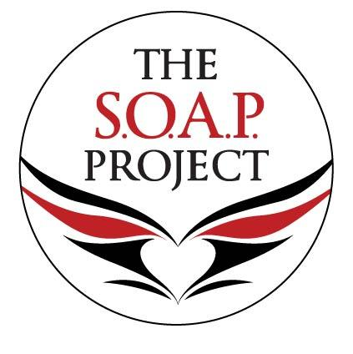
P.O. Box 645
Worthington, OH 43085-0645

The S.O.A.P. Project’s Donor Privacy Policy

Our Commitment to Our Donors

We will not sell, share or trade our donors’ names or personal information with any other entity, nor send mailings to our donors on behalf of other organizations.
This policy applies to all information received by the SOAP Project, both online and offline, on any Platform (‘Platform’, includes the SOAP Project website and mobile applications), as well as any electronic, written, or oral communications.
To the extent any donations are processed through a third-party service provider, our donors’ information will only be used for purposes necessary to process the donation.

